Food Drive Wish List

Representatives of some partner organizations have informed us that many specific food items that their clients need to prepare food that fits their cultures are not usually available from food pantries or the Food Bank. Families especially appreciate receiving these items. Some of them can be purchased at regular grocery stores, and some need to be purchased from specific cultural stores, which we have listed below.

For Puerto Rican, Central American, and South American communities

These items can be purchased at a regular grocery store, in the international section and spice section. Price Rite at 117 Gold Star Boulevard has all these items too.

Beans: (dried or canned)
- Pink beans
- Pinto beans
- Garbanzo beans
- Green pigeon peas
- Red kidney beans
- Small red beans
Flour
- All purpose
- Corn meal
- Masa harina (white corn flour for making tortillas)
Rice
- Medium grain – white
- Long grain – white
Canned tomatoes – whole, especially plum tomatoes
Seasonings
- Adobo
- Sofrito
- Sazon (any type)
- Oregano
- Garlic powder (not garlic salt)
- Onion powder
- Chili powder

For Afghan and other Middle Eastern communities

Some of these items need to be purchased from specific cultural stores, which include:
- Bahnans, 344 Pleasant Street, Worcester
- Fresh Farms, 560 Lincoln Street, Worcester
- India Market, 1000 Boston Turnpike, Shrewsbury (in plaza with Christmas Tree Shop)

Beans
- Lentils – two kinds:
  - Red - can purchase at grocery store
  - Large yellow (channa lentils) – need to get from cultural stores
- Dried chickpeas
- Dried red kidney beans
Rice
- Basmati – white only, 10 lb bags are best
- Sela – only found in cultural stores
Flour
- All purpose (white)
- Chapati flour – found in cultural stores
Canned tomatoes
- Whole peeled or paste
Cooking oil – vegetable or olive
Sugar
Honey
Dried fruit especially dates
Tea – loose leaf, not tea bags
- Black tea
- Green tea (“green gunpowder”) is especially appreciated)
Spices
- Turmeric
- Coriander
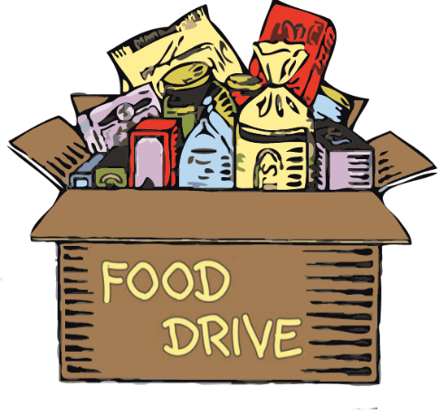
- Cumin
- Black pepper – powder or corns
- Salt

Thank you!

